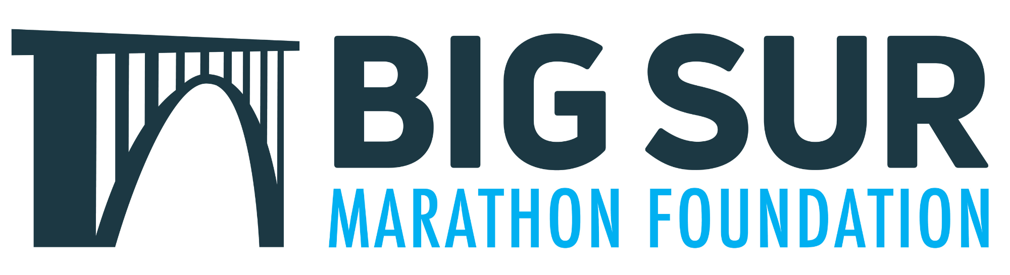

The BSMF Community Grants Program application window is now open, providing funding to support local nonprofit programs that promote youth fitness, healthy lifestyles, and community well-being here on the Monterey Peninsula and throughout Monterey County.

Application window: March 1st-May 1st

Organizations may request $500-$25,000 for special projects or new/expanded programs that align with our mission. Eligible applicants include local 501(c)(3) nonprofits, school-based programs, and community organizations with a fiscal sponsor. Grants are intended for program initiatives rather than routine annual operating expenses.

If you are a volunteer group supporting one or more of our races, applying for, or receiving, a Community Grant will not affect the donation your organization receives through our race volunteer program. These grants are an additional way for us to support the incredible work happening across our community.

This year there will be one grant cycle, and we hope many of you will consider sharing this opportunity with local organizations you partner with.

Full program guidelines and link to apply.

You must apply online using the link above; however, many folks have asked to view the questions prior to applying to help them prepare their materials. Below are the fields you should expect to see when applying for a Community Grant.

Section 1: Applicant demographic info
-First Name
-Last Name
-Email
-Cell phone #
-Address
-What is your role in the organization? (short response)

Section 2: Organizational Information
-Name of Organization (short response)
-If not you, who is your Executive Director/CEO
- Note: include, name, title, email address, and phone number
-History of your organization (long response)
- Note: Provide a brief history of your organization, its programs, and any recent accomplishments
Is your organization an IRS-recognized 501(c)3? YES/NO dropdown
- Note: If not previously submitted, IRS Letter of Determination must be emailed separately to foundation@bsim.org
- If you answered NO, will this grant be managed by a nonprofit fiscal sponsor? YES/NO dropdown
  - Note: 501(c)3 nonprofit fiscal sponsors serve as the grant applicant on behalf of a group which does not have its nonprofits status recognized by the IRS. Fiscal sponsors agree to be responsible for managing grant funds and reporting requirements.
  - What is the name and tax ID of your nonprofit fiscal sponsor? (short response)
-What year was your organization founded? (short response)
-How many members are on your Board of Directors?
-What percentage of your board made a financial contribution to your organization in the past year?
-What is your organization's primary fundraiser?
-State the Mission of your Organization (long response)
-Please share your five largest financial gifts from 2025

Section 3: Grant Project Information
-Title of your project: (short response)
-Amount of request: (short response)
-Proposed activities: (long response, limit 500 words)
- Note: describe the proposed activities, scope of work, general activities (i.e., how grant funds will be utilized)
-Who will benefit from this project (100 words or less)
- Note: Please include how many, age range, ethnicity and geographic area
-What is the expected outcome of this grant? (100 words or less)
- Note: Please share 2-3 measurable goals/objectives you will monitor and report on within one year
-Have any other organizations committed to your project?
- Note: Name each organization and how much was committed to support this project
-In support of the mission of BSMF, we require public recognition for our support of organizations that are in alignment with our mission. If this grant is awarded, how will BSMF be publicly recognized by your organization?
What is the timeline for your project? (short answer)

Section 4: Supporting Documents
Thank you for your interest in our BSMF Community Grant program! To complete your application, please upload the following documents OR submit them to foundation@bsim.org:
- IRS Letter of Determination
- Project budget
- Letter(s) of support as needed
- A list of your current board of directors
- Most recent annual Financial Statement and P&L

If you have questions about eligibility or the application process, please feel free to reach out to us at foundation@bsim.org. Thank you!

